**SuperPy User Guide**

Thank you for using SuperPy, your virtual shop manager.

Before we get started with SuperPy, please note our System Requirements.

|  |
| --- |
| System Requirements:   * Latest version of Python (3.6 or above) * The following Python modules:   + sys   + os   + csv   + argparse   + tkinter   + datetime   + matplotlib   + tkcalendar |

**Installation**

Place the main.py file in a folder of your choice. Additional required files are installed in this folder upon opening the program.

**Using SuperPy**

SuperPy can be used in one of two ways, both of which will be explained in this User Guide.

1. Entirely via the command line, or:
2. Via the User interface

Both methods require you to boot up the terminal. If you are using Windows, use your file browser to navigate to the folder you installed SuperPy. Open that folder. In the folder, right-click on an empty space and select “Open in Windows Terminal”. You have now successfully opened the terminal. You now have the option to choose one of two ways to operate SuperPy

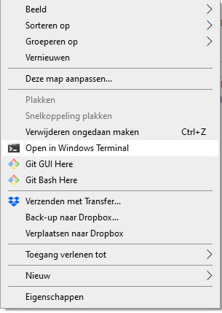

1. **Entirely via the command line**

SuperPy can be used using just the command line in the terminal. A clean and simple method to help you keep track of your shop! You have various commands at your disposal, all of which you can review using the “-h” command in the terminal. To use that command, enter “python main.py -h” in your terminal and press enter. You will see various options:

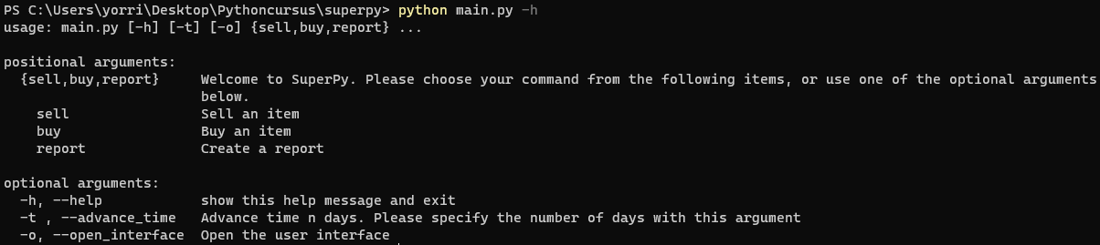

every command you use has to start with ““python main.py” followed by whatever command you like. We will review them all:

|  |  |
| --- | --- |
| buy | Buy an item, meaning you add an item to your stock. |
| sell | Sell an item |
| report | Create a report |
| -t or “--advance_time” | Change the date stored as the system date |
| -o or “--open_interface” | Open the user interface |
| -h or “--help” | View the help options |

Buy

This action allows you to add items to your inventory. More information is needed to process this action, so the command buy must always be accompanied with the following arguments:

|  |  |
| --- | --- |
| --product_name | The name of the product |
| --price | How much did you pay for it? |
| --expiration_date | When does the product expire? Use YYYY-mm-dd format |
| --buy_date | (Optional) When did you buy it? Use YYYY-mm-dd format If this information is not provided, current system date will be used. |

Example: this command results in an apple being added to the inventory



Sell

This action allows you to sell items. More information is needed to process this action, so the command buy must always be accompanied with the following arguments:

|  |  |
| --- | --- |
| --product_name | The name of the product you sold |
| --price | How much did you sell it for? |

Example: this command results in selling an apple for 5.00  


Remember! You can only sell items in your inventory

Report

SuperPy allows you to generate various reports about your business, to keep track of your inventory and cashflow. The report command combines with other commands:

|  |  |  |  |
| --- | --- | --- | --- |
| **Command** | **What does it do?** | **Use with** | **Result** |
| inventory | See what is in stock. | --now --yesterday --date “YYYY-mm-dd” | View current inventory  Yesterday’s stock  Stock on date provided |
| revenue | Review your revenue | --today --yesterday --date “YYYY-mm-dd”  --period “YYYY-mm-dd-YYYY-mm-dd” | View today’s revenue  Yesterday’s revenue  Revenue on date provided  Revenue over a given period |
| profit | Review your profit | --today --yesterday --date “YYYY-mm-dd”  --period “YYYY-mm-dd-YYYY-mm-dd” | View today’s profit  Yesterday’s profit  Profit on date provided  Profit over a given period |

Please note that your inventory is saved as a separate CSV file in your SuperPy folder for your convenience.

Example1

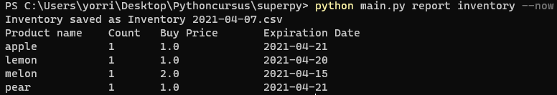

Example2



Example3



-t or “--advance_time”

If, for any reason, you should want to change the current system date, you may do so by using the -t or “--advance_time” command. Use this with a number (either positive of negative) to adjust the current date with that number of days.

-o or “--open_interface”

This command opens the user interface, the second way of using SuperPy to your advantage. More about that in section 2: Via the User interface.

1. **Via the User interface**

Using the -o or “--open_interface” command in the command line opens up the user interface:



Upon opening, the window looks like this

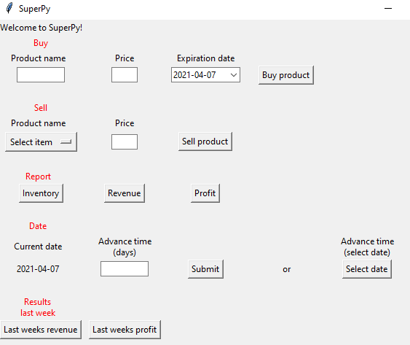

The actions you can take from this screen are similar to the ones you execute from the command line, being:

Buy

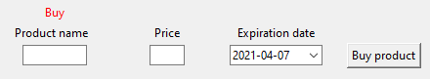

Fill in the product name and price and select the expiration date from the calendar. After that, hit the “Buy product” button to add the item to your inventory.

Example: filling in “pie”, “2” and “2020-04-20” results in

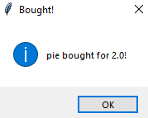

Note: always provide a product name, price and expiration date before clicking the button.

Sell

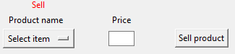

If you want to sell an item from your inventory, click “Select item” and select the item you want to sell. The menu shows all items available to sell. Provide the right price and click “Sell product” to register the sale.

Example: the result of selling a “pie” for 15:

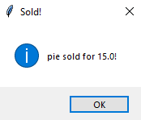

Note: always select an item and provide the price.

Reports



Reports for your inventory, revenue and profit can be generated from this window as well. For inventory, you have multiple options. Clicking the button will open up a new window:

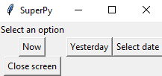

Click the Now button to view current inventory, Yesterday for yesterday’s inventory or provide a different date. Doing so will generate a CSV file in your SuperPy folder and also open up a new window with the result.

Example:

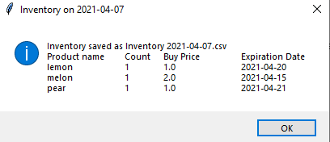

Revenue and profit

Both screens work in a similar way to how the inventory screen handles. Click one of the options or provide a custom date or period to review the revenue or profit for that period.

Example:

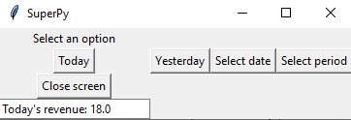

Date

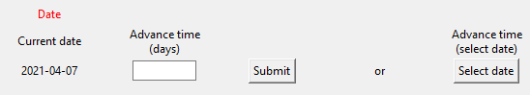

This section shows you the current system date. You can adjust this date in one of two ways:

* + use the Advance time function by specifying a number to advance the time (either positive or negative) and hitting the Submit button, or
  + selecting a new system date using the Select date button.

Both will adjust the current system date.

Results last week

As a true businessperson you are always interested in the latest financial news of your business. The main screen of SuperPy provides two buttons that will show you how your business has been doing over the last week.

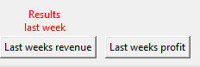

Clicking one of these buttons will open up a bar graph showing you your results for the past week.

Example:

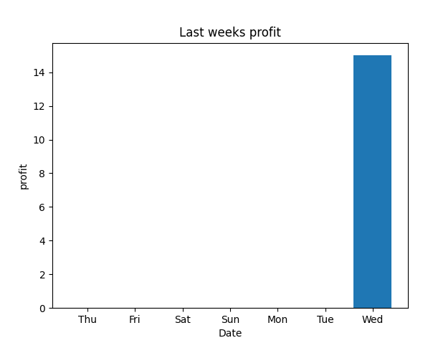

**You are all set!**

Now you know how to use SuperPy, a simple but efficient tool to help you become a millionaire. Please contact the creator of SuperPy if you encounter problems of would like to offer suggestions for further improvement.